NEWS RELEASE
COBBLESTONE HOTELS, LLC BREAKS GROUND ON MINNESOTA LOCATION
June 16, 2021 – NEENAH, WISCONSIN – Cobblestone Hotels announced the groundbreaking of the coming soon Cobblestone Hotel & Suites in International Falls that took place Tuesday, June 15, 2021.
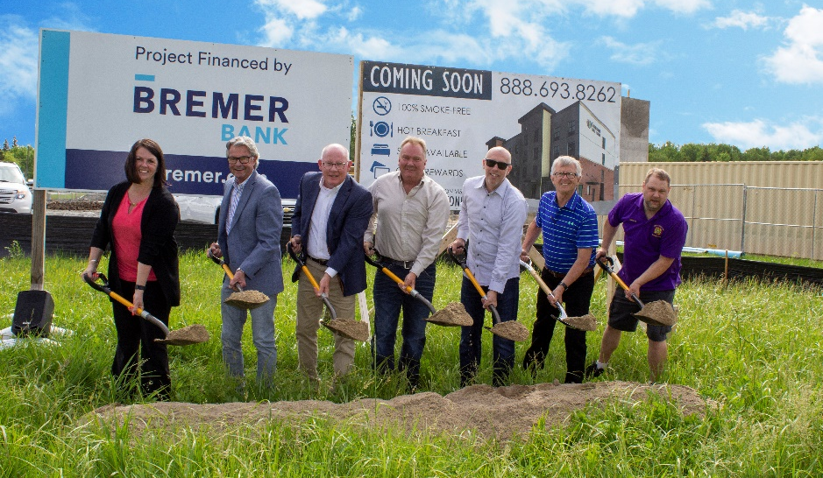
Paul Nevanen, the Director of the Koochiching Economic Development Authority, kicked off the ceremony. He noted this is the first hospitality project that has been built in International Falls since the late 1980s.
Mayor Harley Droba also joined the ceremony and noted the growth International Falls is experiencing. From new businesses to street development, everything that has been accomplished in the last year is part of the vision to continue to grow International Falls with recreation and tourism.
“This has been one of the most unique projects we’ve had.” Said Brian Wogernese, CEO of Cobblestone Hotels. “We came to International Falls only weeks before everything shut down, everything else to get this project moving were held virtually. But we knew that first day we came here, that with this group and the community we were working with, this was going to happen”
The Cobblestone Hotel & Suites will consist of four floors and eighty-six guest rooms. This location will be located on the corner of US Highway 53 and Memorial Drive. Additionally, the hotel will feature the brand’s consistent amenities such as an onsite convenience store, complimentary high-speed internet access, on-site guest laundry, and onsite restaurant and bar, Starbucks Coffee, fitness center, and a complimentary breakfast served daily.
Guestrooms are perfectly tailored to meet the needs of modern travelers, while tastefully designed with an element of contemporary elegance. Amenities include flat-screen TVs, additional recharge outlets for electronics, microwaves, mini refrigerators, in-room coffee brewers, hairdryers, iron and ironing boards, desks, luxury linens, and bathroom essentials.
For updates on the progress of this location and others, please “like” Cobblestone Hotels on Facebook: https://www.facebook.com/cobblestonehotels/
Whether you are traveling for business or for leisure, you will experience the big city quality, and small town values that each location has to offer. Visit www.CobblestoneHotels.com for reservations or for more information.
About Cobblestone Hotels
Based in Neenah, WI Cobblestone Hotels, LLC is a leading upper-midscale hotel brand with over 160 hotels open, under construction, or in development in 27 states. The company continues to pride itself in filling the lodging needs of communities through its upper mid-scale new build brand. Signature amenities include high-speed Internet access, complimentary breakfast, convenience store, fitness centers, business centers, and more.

Cobblestone Hotels includes Cobblestone Hotels & Suites, Cobblestone Inn & Suites, Boarders Inn & Suites, Centerstone Hotels, and KeyWest Hotels. For development information please visit www.CobblestoneFranchising.com.

Cobblestone Hotels offers the Cobblestone Rewards frequent stayer program where guests receive ten points for every dollar spent, and can be redeemed as award nights, or with other redemption partners. For more information visit www.CobblestoneRewards.com

Contact: marketing@staycobblestone.com

