NEWS RELEASE
COBBLESTONE HOTELS, LLC SIGNS LYNDEN, WASHINGTON
October 14, 2021 – Neenah, WI – Cobblestone Hotels announced the signing of the coming soon Cobblestone Hotel & Suites in Lynden, Washington, the first location in the state of Washington.

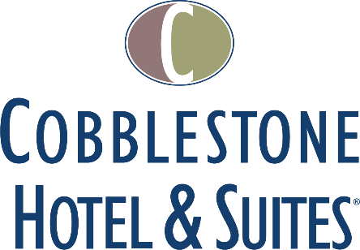

The Cobblestone Hotel & Suites will consist of four floors and sixty-eight guest rooms. Additionally, the hotel will feature the brand’s consistent amenities such as an onsite convenience store, complimentary high-speed internet access, on-site guest laundry, Starbucks Coffee, fitness center, and a complimentary breakfast served daily.
Guestrooms are perfectly tailored to meet the needs of modern travelers, while tastefully designed with an element of contemporary elegance. Amenities include flat-screen TVs, additional recharge outlets for electronics, microwaves, mini refrigerators, in-room coffee brewers, hairdryers, iron and ironing boards, desks, luxury linens, and bathroom essentials.
The Wissota Chophouse will specialize in steaks and features creative appetizers like Buffalo Alligator and Bacon Bleu Truffle Fries. An example menu can be viewed at www.wissotachophouse.com and selecting the other others dining menu. The restaurant will have a full bar, and feature over 20 wines by the glass, 20 craft beer taps, creative spirits, and a patio.
For updates on the progress of this location and others, please “like” Cobblestone Hotels on Facebook: https://www.facebook.com/cobblestonehotels/
Whether you are traveling for business or for leisure, you will experience the big city quality, and small town values that each location has to offer. Visit www.CobblestoneHotels.com for reservations or for more information.
About Cobblestone Hotels
Based in Neenah, WI Cobblestone Hotels, LLC is a leading upper-midscale hotel brand with over 160 hotels open, under construction, or in development in 29 states. The company continues to pride itself in filling the lodging needs of communities through its upper mid-scale new build brand. Signature amenities include high-speed Internet access, complimentary breakfast, convenience store, fitness centers, business centers, and more.

Cobblestone Hotels includes Cobblestone Hotels & Suites, Cobblestone Inn & Suites, Boarders Inn & Suites, Centerstone Hotels, and KeyWest Hotels. For development information please visit www.CobblestoneFranchising.com.

Cobblestone Hotels offers the Cobblestone Rewards frequent stayer program where guests receive ten points for every dollar spent, and can be redeemed as award nights, or with other redemption partners. For more information visit www.CobblestoneRewards.com

Contact: marketing@staycobblestone.com

